DIGITAL LITERACY PROJECT REPORT (CSE0001)

1. Title Page
Project Title: Digital Literacy Project
Course Code: CSE0001
Student Name: Hardik Godara
Registration Number: 22BET10046
University: VIT Bhopal
Date: 30/03/2026

2. Objective
The objective of this project is to develop digital literacy skills by effectively using modern digital tools and platforms. This project focuses on improving communication, collaboration, cybersecurity awareness, and building a strong professional digital presence.

3. Tools and Platforms Used
- Canva – for poster designing
- LinkedIn – for professional networking
- GitHub – for project hosting and version control
- Google Docs, Sheets, Slides – for collaboration
- Gmail – for formal communication

4. Task 1: Digital Poster Creation
A digital poster was created using Canva on the topic “Cyber Safety Awareness”.
Content Included:
- Importance of strong passwords
- Avoiding phishing emails
- Safe browsing practices
- Data privacy tips
Steps Followed:
- Open Canva and select poster template
- Choose cybersecurity theme
- Add icons and visuals
- Insert informative text
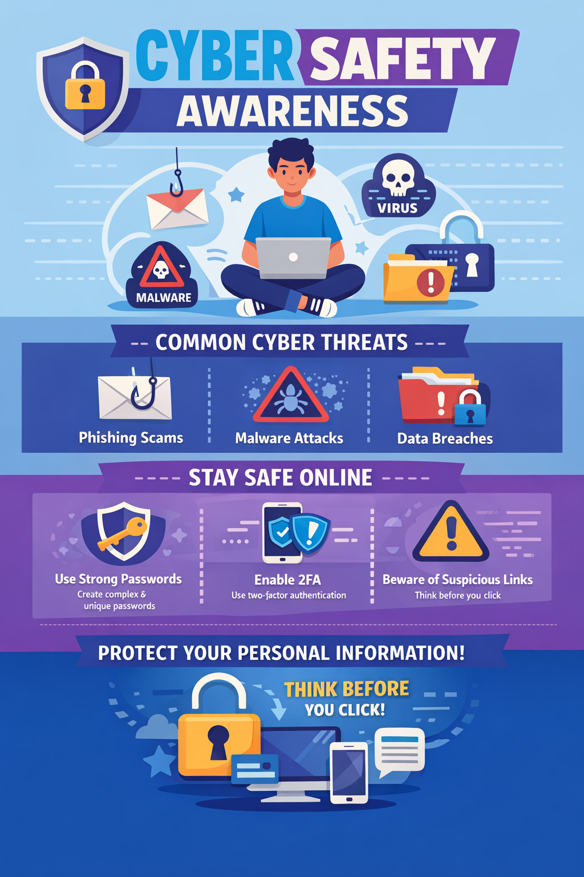

5. Task 2: LinkedIn Profile Creation
A professional LinkedIn profile was created.
Details Added:
- Profile photo
- Headline: Student | Tech Enthusiast
- About section (summary)
- Education details
- Skills (e.g., Communication, Problem Solving, MS Office)
Sample About Section: I am a motivated student with a keen interest in technology and digital tools. I am passionate about learning new skills and improving my digital literacy to adapt to modern professional environments.
Profile Link: https://in.linkedin.com/in/hardik-godara-11b47564

6. Task 3: GitHub Repository Creation (IMPORTANT)
A GitHub repository was created to host this project.
Repository Name: Digital-Literacy-Project
Steps Followed:
- Create GitHub account
- Click on “New Repository”
- Add repository name
- Upload project files
- Add README.md file
Repository Structure:
Digital-Literacy-Project/
│── README.md
│── report.pdf
│── poster.png
│── screenshots/
│ ├── linkedin.png
│ ├── github.png
│ ├── email.png
│ └── google_tools.png
GitHub Link:

7. Task 4: Google Tools Usage
Google tools were used for collaboration and productivity.
Activities:
- Created document using Google Docs
- Designed presentation using Google Slides
- Managed data using Google Sheets
- 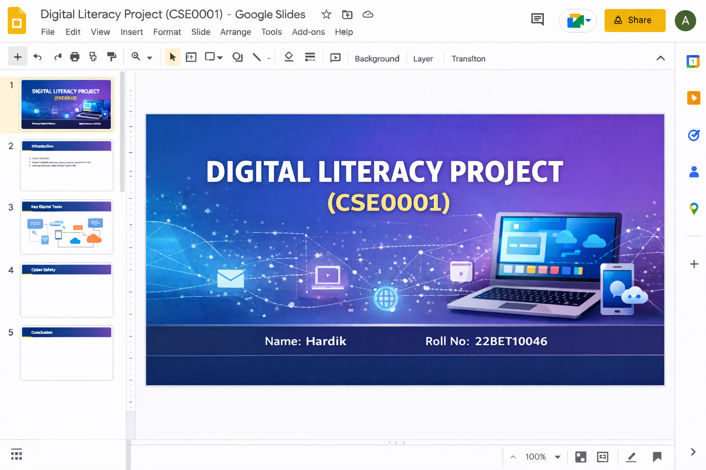

8. Task 5: Email Writing
A formal email was written using Gmail.
Sample Email:
Subject: Submission of Digital Literacy Project
Dear Sir/Madam,
I hope you are doing well. I am writing to inform you that I have successfully completed and uploaded my Digital Literacy Project. Kindly review the submission and provide your feedback.
Thank you for your time and support.
Yours sincerely,
Hardik Godara

Here is the screenshot of the same.
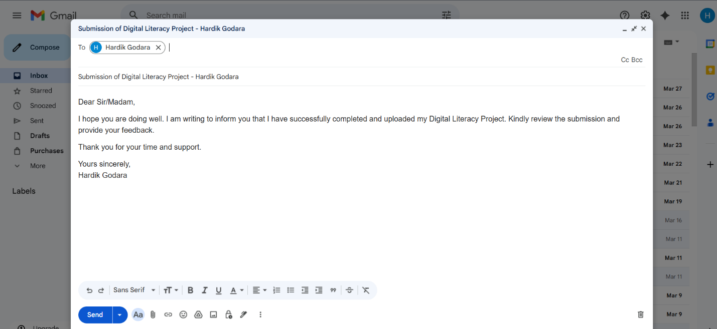

9. Task 6: Cybersecurity Awareness
The following concepts were learned:
- Phishing attacks and prevention
- Malware and antivirus usage
- Importance of strong passwords
- Two-factor authentication
- Safe internet browsing

10. Learning Outcomes
- Developed digital communication skills
- Learned to use professional platforms
- Improved collaboration using online tools
- Gained awareness of cybersecurity risks
- Built a professional digital portfolio

11. Conclusion
This project provided hands-on experience with essential digital tools and platforms. It enhanced my ability to communicate professionally, collaborate online, and maintain cybersecurity practices. These skills are crucial for academic and professional success.

